Project 1 KRR

Ana-Maria Partu

407

1. KB:

1.Anybody who is lucky or smart is rich

2.Anyone who is rich has a helicopter

3.No one who has a helicopter rides a bike

4.John rides a bike

Q: Is Jon not lucky?

1. FOL:
$$∀x.Lucky\left(x\right) ˅ Smart\left(x\right) ⊃Rich\left(x\right)$$

$$∀x.Rich\left(x\right) ⊃Helicopter\left(x\right)$$

$$¬∃x.Helicopter\left(x\right) ˄ Bike\left(x\right)$$

$$Bike(john)$$

$$Q: ¬Lucky(john)$$

2. CNF:

$$\left[¬l,r\right],\left[¬s,r\right],\left[¬r,h\right],\left[¬h,¬b\right],\left[b\right],[l]$$

KB U {¬α} is unsatisfiable :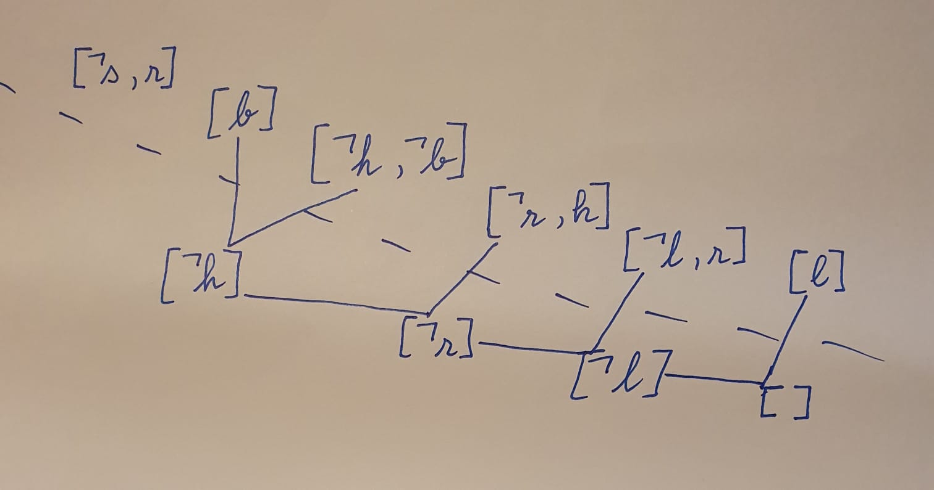

1. For every pair of different clauses, the algorithm checks to see if it can apply the resolution on them. If it is possible, the unification is added to a list that is then added to the KB. This makes the algorithm run in a Breadth First Search manner. If after a KB update nothing has changed, the initial set of clauses is satisfiable.

2. The • operation is a procedure which is applied to a set of clauses and an atom and the result is new set of clauses. This works by eliminating all clauses which contain the chosen atom, and eliminating the complement of the atom from the rest of the clauses.

Davis-Putnam SAT procedure is an algorithm for determining the satisfiability of a set of clauses. This is done by repeatedly applying the • operation in conjunction with a chosen atom or it’s complement. The set of clauses is satisfiable iff we get {} – the empty set. If the empty clause is present in the set, it is unsatisfiable. There are multiple strategies of selecting the atom for the • operation which impact the performance of the algorithm.

The 2 strategies of selection of the atom to perform the • operation I chose are: the atom which appears in the shortest clause in the set of clauses and the atom which appears in the most clauses. By comparing the number of recursion steps taken by each strategy, we can tell that, based on the short sets of clauses given as examples, choosing the atom which appears in the shortest clause made the algorithm perform better. However, given a large set of clauses, choosing the atom which appears in the most clauses should perform better by eliminated more clauses at each step of the • operation.